For the last term and a half, staff have been focussed on supporting and encouraging children to develop the characteristic of effective learning `to play and explore’. This half term we will focus on persistence and perseverance.
Keep on trying - Learning to bounce back from difficulties and challenges, having self-belief and the ability to change strategies are linked to the importance of learning persistence. When babies and children learn to keep going in the face of something that is just out of reach, something that may be frustrating, difficult, demanding, then the importance of persistence becomes clear. The feeling of self-pride and that wow feeling of overcoming difficulties supports them to continue to challenge themselves.

EYFS Knowledge Organiser: Dinosaurs (Pandas)
Personal, Social and Emotional Development  To engage with others through gestures, gaze and talk  We will be playing dinosaur themed games, singing songs and taking turns with resources. | Communication and language  To copy your gestures and words.  We will be reading lots of dinosaur books and singing songs. We will have a big focus on describing and naming words (long neck) | Physical development  To start eating independently (hold own spoon, learn how to use a knife and fork.)  We will have a strong focus on encouraging children to hold their own cutlery, praising and modelling.  We will play games where we move and act like dinosaurs. | Literacy  To develop play around favourite stories using props  The Pandas love to pretend play however this half term we are focussing on deepening that play and using stories as a basis. We will use small world and story sacks as well as everyday resources to support us.
Maths  To react to changes of amount in a group of up to 3 items.  We will be using dinosaur toys to count, order and describe position.  We will sing number songs and use objects to reinforce. | Understanding the World  To repeat actions that have an effect.  We will be learning about St David’s day celebrations and Mother’s Day  When exploring dinosaurs we will play with dinosaur toys & share books, modelling vocabulary and linking to sharing and turn taking. | Expressive arts and design  To start to develop pretend play, pretending that one object represents another.  The Pandas love to pretend play however this half term we are focussing on deepening that play and using everyday object such as boxes (caves) or tubes (bones) as props. | 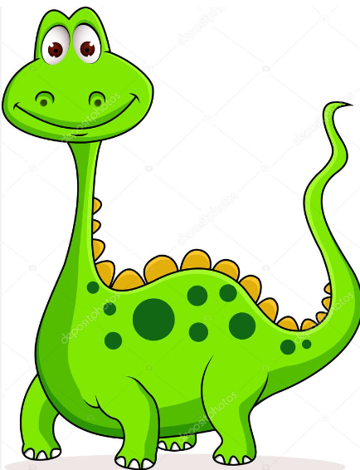
For the last term and a half, staff have been focussed on supporting and encouraging children to develop the characteristic of effective learning `to play and explore’. This half term we will focus on persistence and perseverance.
Keep on trying - Learning to bounce back from difficulties and challenges, having self-belief and the ability to change strategies are linked to the importance of learning persistence. When babies and children learn to keep going in the face of something that is just out of reach, something that may be frustrating, difficult, demanding, then the importance of persistence becomes clear. The feeling of self-pride and that wow feeling of overcoming difficulties supports them to continue to challenge themselves.
EYFS Knowledge Organiser: Dinosaurs (Koalas)
Personal, Social and Emotional Development  To notice and ask questions about differences  To talk about their feelings using words like ‘happy’, ‘sad’, ‘angry’ or ‘worried’.  We will explore the world of Elmer on book day, but also look at the similarities and differences between the dinosaurs. We will wonder why some fly or swim.  We will also begin a big push on thinking about and naming our feelings. | 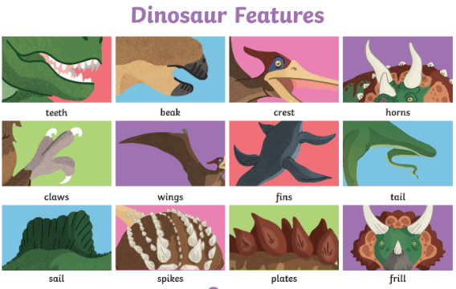  Communication and language  To begin to understand simple questions about ‘who’, ‘what’ and ‘where’ and `why’ | Physical development  To show an increasing desire to be independent, such as wanting to feed themselves and dress or undress.  To increasingly be able to use and remember sequences and patterns of movements which are related to music and rhythm.  How do dinosaurs move? Do they stamp? Stomp? Slide? We are going to find out and be those creatures. We will also be learning new dinosaur action songs and doing sticky kids. | Literacy  To ask questions about the book.  Make comments & shares their own ideas.  We all love stories, but books need to be talked about, explored and our favourite parts or pictures decided. We will also be looking carefully at books and asking questions
Maths  To develop counting-like behaviour, such as making sounds, pointing or saying some numbers in sequence.  We will be using dinosaur toys to count, order and describe position. We will play with dinosaur bones, counting and comparing them. | Understanding the World  To make connections between the features of their family and other families  We will be learning about St David’s day celebrations and exploring the importance of mums in our families and around the world.  When exploring dinosaurs we will play with dinosaur toys & share books: encouraging and modelling talk about similarities and differences | Expressive arts and design  To start to develop pretend play, pretending that one object represents another.  The Koalas love to pretend play however this half term we are focussing on deepening that play and using everyday object such as boxes (caves) or tubes (bones) as props. | 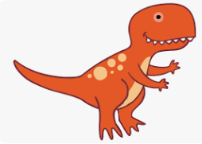
For the last term and a half, staff have been focussed on supporting and encouraging children to develop the characteristic of effective learning `to play and explore’. This half term we will focus on persistence and perseverance.
Keep on trying - Learning to bounce back from difficulties and challenges, having self-belief and the ability to change strategies are linked to the importance of learning persistence. When babies and children learn to keep going in the face of something that is just out of reach, something that may be frustrating, difficult, demanding, then the importance of persistence becomes clear. The feeling of self-pride and that wow feeling of overcoming difficulties supports them to continue to challenge themselves.

EYFS Knowledge Organiser: Dinosaurs (Bears)
Personal, Social and Emotional Development  To play with one or more other children, extending and elaborating play ideas.  We Bears have amazing imaginations. We will now begin extending our play and ideas, using our words and curiosity to take our learning further. | Communication and language  Use longer sentences of four to six words.  Dinosaurs, world book day, comic relief, Mother’s day and Easter… We have so much to discuss! | Physical development  Use one-handed tools and equipment, for example, making snips in paper with scissors.  We love to cut and collage. Now is the time to build on those cutting skills and gain accuracy.  We will also be beginning to have more opportunities to write our names and other sounds we hear, copying the shapes of the letters using pencils, crayons, pens and brushes | Literacy  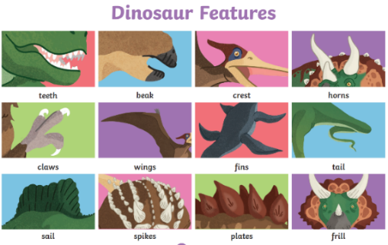  To engage in extended conversations about stories, learning new vocabulary.
Maths  To compare quantities using language: ‘more than’, ‘fewer than’.  We all know when someone has more sweets than us, but now we will be using those words in our play. Who has more toys? Do we need more brushes? | Understanding the World  Talk about what they see, using a wide vocabulary.  We will be learning about St David’s day and Mother’s day as well as exploring the Christian and Secular celebrations of Easter.  We will be making cards, collaging and painting flags and more.  We will be learning about dinosaurs and fossils and going on dino hunts and doing dinosaur digs, searching for bones, looking at books to work out which dinosaur they may have belonged to. | Expressive arts and design  To begin to develop complex stories using small world equipment like animal sets, dolls and dolls houses, etc.  We can all use our cars on the track or push the dollies in the pram, but now we will be racing drivers tearing around bends with Lightening McQueen close behind, or taking our dolly to the doctor because it has a cough. Just adding that extra element of storyline to enhance the play | 