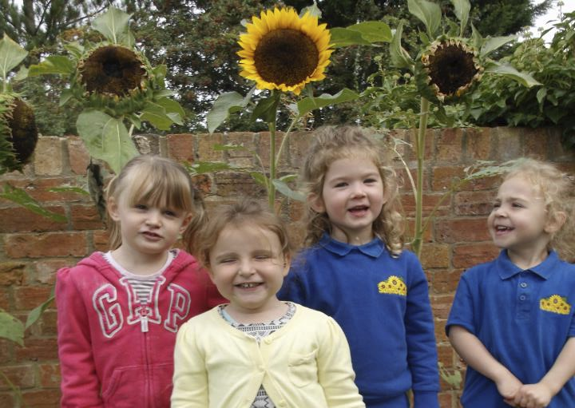

Back Lane, Pebworth, CV37 8XA

Contact details
Pebworth - 01789 507270 pebworth@sunflowers.me.uk
Sue Henson - Owner of Sunflowers
07495 029550 sue@sunflowers.me.uk
www.sunflowers.me.uk

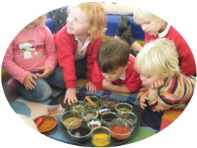
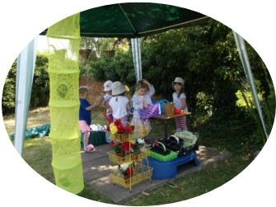

At Sunflowers, we believe, play is the way in which young children find out about their world and acquire, practice and refine their emerging skills.

Play occurs naturally in children, so
through their play children develop
physical, intellectual, linguistic, social and emotional skills and concepts.

Adults can use children’s eagerness to play and to create an effective learning environment.

A well-planned, rich and stimulating play
environment will provide opportunities for
children to explore the world and adapt
and refine their understanding of it.

You can rest assured that your child will be cared for with the upmost kindness, love and
respect.

“We believe every child is a precious gift and we treat them as though they were our own”

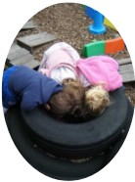
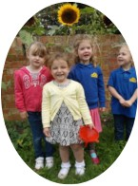
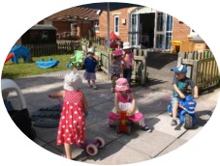

Sunflowers is owned managed by Sue Henson (N.N.E.B) an experienced childcare
practitioner and working mother. Sue took over the business in October 2010 and has
worked closely with the local community to expand and improve the childcare provision on
offer.

Sunflowers aim to provide affordable childcare to meet the individual needs of both
children and parents by offering a warm, friendly, safe and stimulating environment where children can flourish and develop their full potential.

Sunflowers offer flexible sessions to meet parents’ and carers busy lifestyles.

Sunflowers Nursery Pebworth is within Pebworth First
School with a separate access door off the School Playground

“Sunflowers offer a warm homely environment where your child will get all the attention and care they need”

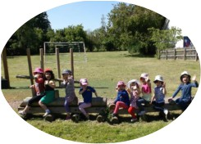
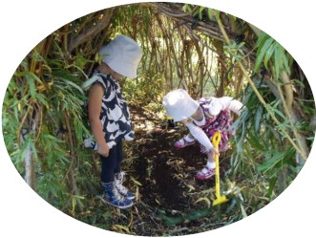

• 30 places available for children aged 3 months to 4 years
• Open from 8.00am - 5.00pm Monday to Thursday and 8.00am to 4.30pm Fridays.
• Open 51 weeks of the year only closed Bank holidays and between Christmas and
New Year
• Experienced qualified staff with a real passion for childcare
• Welcoming homely environment
• Free Nursery (NEF) places 15 and 30 hours for children aged 3 that are not
restricted to term time only and can be used over a stretched period
• Free NEF places for children aged 2
• Regular booked sessions
• Ad-hoc sessions
• Open door policy - Parents are welcome at any time to view the Pre-School no
appointments required
• Excellent location in the ground of Pebworth First School
• Close integration with the school including joint activities with the Reception class
• Access to fantastic outdoor facilities all year-round play surfaces

Early Years Foundation Stage (EYFS)
At Sunflowers we aim to provide a happy, secure environment where play is encouraged to foster learning. Play occurs in a well-planned learning environment both inside and outdoors following the interests of individual children.

We are guided by the Early Years Foundation Stage framework
(EYFS) for all age groups, following children’s development from birth to the end of their first year in school.
There are four guiding principles of the EYFS, and they shape the practices we follow at Sunflowers they are;-

Unique Child

“Every child is a unique child,
who is constantly learning and
can be resilient, capable,
confident and self-assured”

Positive Relationships

“Children learn to be strong and independent through positive relationships.”

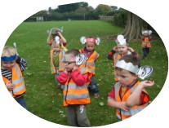
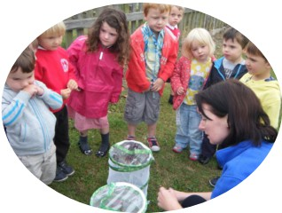
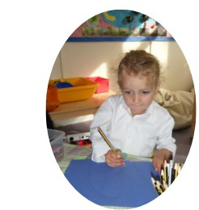

Enabling Environments

“Children develop and learn in
different ways and at different
rates and all areas of learning
and development are equally
important and inter-connecting”

Learning & Development

“Children learn and develop well
in enabling environments, in
which their experiences respond
to their individual needs and
there is a strong partnership
between practitioners and
parents and/or carers”

Learning and Development is split into 7 different learning areas they are:-
Communication and Language development involves giving children opportunities to experience a rich language environment, to develop their confidence and skills in expressing themselves and to speak and listen in a range of situations.

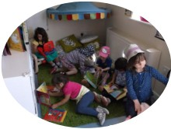
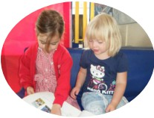
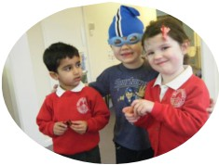
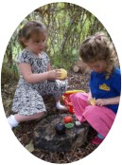
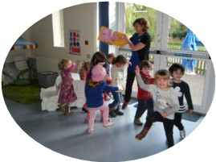
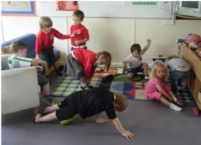

Physical Development involves providing opportunities for young children to be active and
interactive; and to develop their co-ordination, control and movement. Children must also
be helped to understand the importance of physical activity and to make healthy choices in
relation to food.

Personal, social and emotional
development involves helping
children to develop a positive
sense of themselves and others;
to form positive relationships and
develop respect for others; to
develop social skills and learn how
to manage their feelings; to
understand appropriate behaviour
in groups; and to have confidence
in their own abilities.

Literacy development involves encouraging children to link sounds and letters and to begin to read and write. Children must be given access to a wide range of reading materials
(books, poems, and other written materials) to ignite their interest.

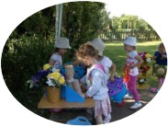
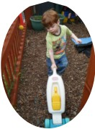
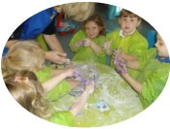
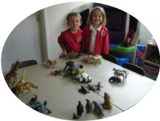
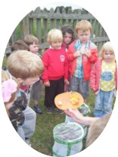
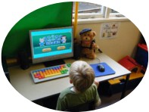
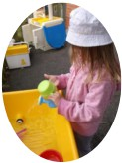
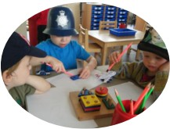

Mathematics involves providing
children with opportunities to
develop and improve their skills
in counting, understanding and
using numbers, calculating simple
addition and subtraction
problems; and to describe
shapes, spaces, and measures.

Understanding the world involves guiding children to make sense of their physical world and their community through opportunities to explore, observe and find out about people, places, technology and the environment.

Expressive arts and design involves enabling children to explore and play with a wide range of media and materials, as well as providing opportunities and encouragement for sharing their thoughts, ideas and feelings through a variety of activities in art, music, movement, dance, role-play, and design and technology.

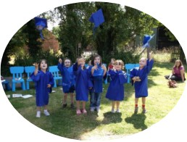

Throughout Sunflowers, all planned learning activities are created after carefully observing the needs and interests of the children.
A mixture of adult led activities and child initiated play, based around a central theme along with structured planning will provide stepping stones for children to thrive and achieve their full potential.
Focused activities show differentiation in children’s ages and abilities to ensure their
individual learning objectives are addressed as not all children learn in the same way.

Your child will have their own personal ‘Learning Journey’ in which you will be able to see all sorts of masterpiece’s your child has created, along with observations of their interaction with others or concentration on specific tasks.
On a termly basis, your child’s ‘Key Person’ will provide you with a written progression
summary celebrating your child’s achievements within the 7 areas of learning and
development as set out by the EYFS. This will also include lots of artwork, mark making,
writing, pictures and observations showing you their ‘Learning Journey’ with Sunflowers.

We also encourage parents and carers to
contribute to their child’s Learning Journey and share with us things like holiday photos and
adventures they may have had.

When you child is ready to move onto school from Sunflowers we celebrate this milestone
with a Graduation Ceremony where we invite parents and family to share this wonderful
event

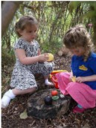
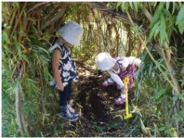
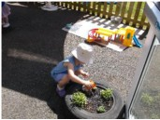
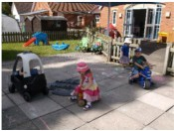

Sunflowers Pebworth have a fantastic outdoor space where children can experience play and exploration in many different environments.
We have a large paved area where the children can ride bikes and scooters, they can chalk on the ground, play games with bats and balls and boasts a fantastic mud Kitchen where
the children have a wonderful time baking lots of wonderful creations and get very
messy alongside generating all sorts of wonderful adventures in the wooden play house.

There is a fantastic - developing - sensory area, created with the children, drawn from their ideas and feedback which provides endless opportunities for exploration and eco therapy. It also offers opportunities for role play and small world adventures when hunting for dinosaurs and other beast big and small or creating fairy gardens.

The last area is a large grassed area which includes slides, water play, obstacle courses, sand play and a fabulous construction area which looks out onto a working farm!
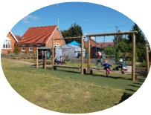
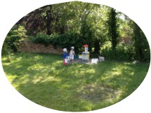

We also have access to the school grounds - which the children love!

This routine is to be used as a guide to help structure the day - if the children are engrossed in the play activity then they will not be asked to stop

8.00 - 8.30 Breakfast - self selection
8.45 Breakfast club children go to school
9.00 - 9.15 Circle Time (hello song, story, rhymes, show and tell)
9.15 Free-flow play with opportunity to join in a focussed activity
10.00 Morning snack on offer - self-selection (milk & fruit)
10.15 - 11.45 Outdoor and indoor - free-flow play including opportunity to join
in a focussed activity
11.45 - 12.30 Lunch Period
12.30 - 1.00 Quiet activities and rest opportunity if required
1.00 - 1.15 Brush our teeth
1.15 – 1.30 Circle Time (hello song, story, rhymes, show and tell)
1.30 – 2.00 Free-flow play with opportunity to join in a focussed activity
2.00 – 2.15 Afternoon snack on offer - self-selection (milk & fruit)
2.15 - 3.30 Outdoor and indoor - free-flow play including opportunity to join
in a focussed activity
3.10 Out of school club children arrive

3.30 - 4.45 Outdoor and indoor - free-flow play including opportunity to join
in a focussed activity. Home work opportunity for OOSC
4.30 Short session OOSC go home
4.45 High Tea for all children
5.00 Sunflowers closes.

Nappy checks and toileting are done on regular intervals throughout the day to meet the
individual needs of each child.

All children are encouraged to access all the activities on offer throughout the day.
Children are given 5 minutes’ notice prior to an activity period ending.

OOSC - Out of School Club

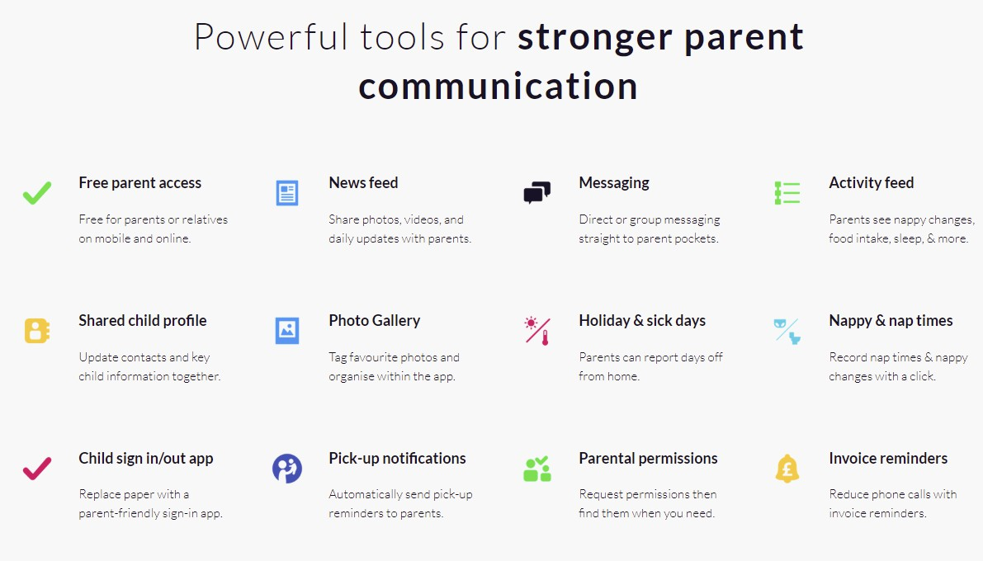

Sunflowers you an application called Famly to communicate with you daily keeping you
updated with any information about your littles ones activities with us - it is a little bit like
Facebook for the Nursery on a secure server so that only Nursery parents have access to
it.
You will need to download the app on your phone and you will be sent an invitation email to join once your child has started at Sunflowers.

https://famly.co

Getting to know us
Before your child starts Sunflowers, it is important that they settle in and get to know their ‘Key Person’. To facilitate this, we will arrange for you to bring your child to
Sunflowers for a couple (or more) ‘settling in’ visits.
This will enable you and your child to become confident and familiar with the staff, as well as our routine.

Meals and Snacks
A variety of nutritious snacks is provided each day. We serve breakfast, light tea and a morning and afternoon snack.
All the staff have their Food Hygiene Certificate; we can also accommodate special dietary requirements.

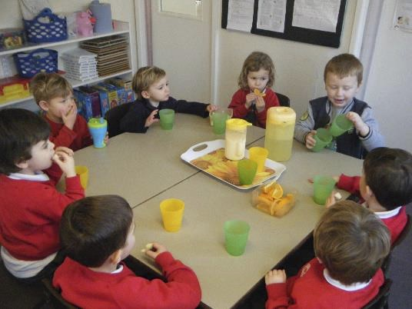
Fresh drinking water is available to the
children at all times and where possible, we ask you to send your child into Sunflowers with a labelled water bottle.

Morning and afternoon snacks are always a selection of fresh fruit and a drink of milk or
water.

Staffing
All Sunflowers Staff hold a Childcare Qualification, NNEB Qualification or are working towards a qualification
Enhanced DBS checks are compulsory for all staff members.

Policies and Procedures
Sunflowers policies and procedures are readily available for you to inspect at any time. Please ask any member of staff if you would like to see them.

Outings
Consent will be required if your child is to attend any nursery outings. These will be conducted in line with nursery policy. Permissions can be found on the FAMLY app.

Sickness
Children will be excluded from nursery for 48hrs following a period of sickness and/or diarrhoea.
Children prescribed antibiotics will be excluded for the first 48hrs. Parents are required to report recent illness to the staff.
Sunflowers will contact parents without delay if their child becomes unwell at nursery to prevent cross infection to the other users.

Medication
Only prescribed medication from the child’s GP can be administered at Sunflowers.
This should be clearly labelled with the date, child’s full name and the prescribed dosage. Staff will fill out a medication form and ask parents to check and sign before they leave their child for the session, and then they will be asked to countersign the form at the end of the day when the medication has been administered.

Accidents and Incidents
Parents and cares are requested to inform nursery staffs of accidents or incidents that
have occurred at home so that the relevant form can be completed. Where minor
accidents or incidents occur at nursery, staff will fill out an accident form which will be
shared with parents when they come to collect their child. If a major accident or incident
were to occur at nursery, parents will be contacted without delay in line with nursery
policy.

Head lice
Parents will be notified regarding any outbreak of head lice. Sunflowers is unable to do
anything when an outbreak occurs other than notify all parents and carers. Good practice is to wash your child’s hair regularly and condition it well; this stops the lice from laying their eggs on the base of the hair follicle. Also to check your child’s hair regularly for lice by combing through with a fine toothed comb.

Sun Screen
During the hot and sunny summer months, children MUST have a sun hat and their own
named sun cream at Sunflowers in order to access the outdoors during these times.

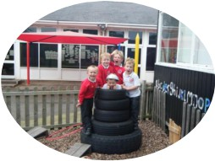

Breakfast Club

Sunflowers provides a Breakfast Club to meet the needs of parents whose children attend Pebworth First School which means that continuity can be provided for those children who move on to the school from Sunflowers Pre-school.

Out of School Club (OOSC)

Sunflowers’ offers an OOSC for Pebworth First School and children from other schools are welcome, they would however, need to be dropped off here.

Holiday Club
Sunflowers during all school holidays and can provide care for children up to the age of 11. We offer a wide variety of activities such as;

• Nature Days
• Science workshops
• Arts & Craft
• Cooking
• Sports Activities

Should you require further
information on the provision for school age children please contact us on pebworth@sunflowers.me.uk

Opening Times - Sunflowers is open Monday to Thursday 8.00am to 5.00pm and 8 to 4.30 on Fridays all year except for Bank Holidays and the week between Christmas and New Year.
Finance - Fees are payable one month in advance on the 14th of each month upon receipt of a monthly invoice. Fees can be paid by either standing order, cash, cheque or childcare vouchers. Cheques will incur £1.50 banking charge
A £25 late payment will be added to the monthly invoice if
sunflowers have not received payment by 20th of each month. If a
further 5 working days’ pass from this date and fees have not
been paid your child will be excluded from Sunflowers until the
outstanding fees have been paid. The only exception to this
would be if prior arrangements have been made between
yourself and the Owner.
Sunflowers reserve the right to increase the fees at any time upon giving one calendar months’ notice. Fee reviews will be conducted annually each February.
Additional sessions - will be invoiced at the end of the calendar month in which they take place.
Change’s to sessions - Should you need to change your child’s sessions on an ad hoc basis you will need to contact the
manager to discuss as it is possible as-long as the child to staff ratios allow it.
Nursery Education Funding (NEF) - If your child is entitled to
NEF you must declare on the Warwickshire / Worcestershire
County Council Parent/Guardian Declaration Form any claims
made at another setting. Failure to declare this information will
result in you repaying us all amounts credited to your account
and subsequently not funded by Warwickshire / Worcestershire
County Council. We are registered to claim NEF on behalf of
eligible children aged three and four years. If your child is
eligible and attends for just the free entitlement / funded hours
there are no other costs involved, however, if additional services
or hours are booked these will be chargeable at our normal fee
rate, and if not already paid a registration fee and deposit will
become payable.
A terms notice is required to cancel NEF session.
Late Collection - Additional charges will made be made for
those children who are late being collected (unless previous
arrangements have been made with the manager). The cost for
the late collection of a child is £5.00 per 15 minutes, or part of.
Refunds - There is a no refund policy of fees for non-attendance or absence of children (including illness) for any part of their
regular sessions or additional sessions booked.
Notice Periods - 1 month’s written notice must be given if you wish to reduce your child’s sessions.
1 Terms notice for all funded children

1 month’s written notice must be given if you wish to withdraw your child from Sunflowers.
Illness - Children suffering from an infectious or communicable disease must not attend Sunflowers, the Manager must be
informed if your child is suffering from any such illness in order that other parents can be notified.
Children suffering with sickness and/or diarrhoea must not return
to Sunflowers until a minimum of 48 hours has elapsed since the
last bout;
If your child becomes ill whilst attending Sunflowers, you will be contacted immediately. It is then the responsibility of the parent to make arrangements regarding the collection of the child;
To ensure optimum safety and security for your child, children can only be collected by nominated adults (aged 18 and over). If a member of staff is not entirely satisfied with a “collectors”
identity, your child will not be allowed to leave our care without further investigation.
Medication - Administration of Medication - Sunflowers staff will only administer medication prescribed by a doctor. A signed and dated consent form must accompany this from the parent.
It is Sunflowers policy NOT to administer Infant Suspension (i.e. Calpol) unless there are extenuating circumstances. In such circumstance, the administration of Infant Suspension will be at the discretion of the Manager. If your child has required Calpol prior to arrival at Nursery, staff must be informed.
General - It is the responsibility of the parents to inform Sunflowers of any changes in contact details
Liability - Sunflowers cannot take responsibility for any personal
items children may bring into Sunflowers. Children should not
bring items of jewellery, watches, money or other valuables into
the building.
Policies & Procedures - a copy of Sunflowers policies and procedures is available on request from the Manager.
Sharing of Information - Sunflowers reserve the right to share
information with other agencies in relation to any Safeguarding
concerns they may have about a child or young person in their
care.

